Roles and access rights
Until now, you have had full access to all sections of the application and to all configuration objects and commands used in these sections. However, in real work of users, one of the main capabilities that the application solution should provide is the differentiation of user access rights to this or that information stored in the information base.
For example, a company manager, obviously, should have access to all information contained in the database, but the storekeeper, on the contrary, only to information concerning the movement of goods in warehouses, and should not be able to view accounting or personnel information.
In addition, it should be possible to restrict users in performing certain actions with database objects. For example, the storekeeper can create and change incoming invoices, since he is responsible for accounting of materials at the enterprise. The sales manager may need to view purchase invoices to know what materials were received and when, but he should not be able to make any changes to purchase invoices.
To differentiate access in 1C, such entities as access rights and roles (which are sets of access rights) are used.
Access rights
In 1C Enterprise, by default, everything that is not allowed is prohibited. There is only one entity responsible for user access to any functionality or data. This entity is called "Access right". It is the only element responsible for access to a specific operating mode, catalog data, attribute, etc.
The number of types of access rights is predetermined by the platform. In total, there are two main groups of access rights in the 1C platform:
- General system-wide access rights to platform mechanisms, responsible for access to certain platform operating modes (Administration, Exclusive Mode, Thin Client, Interactive opening of external reports, etc.).
- Object access rights, allowing users to work with various configuration objects. Their number depends on the type of configuration object. For example, a catalog has 16 different types of access (Read, Add, Change, Delete...). There are only five types of access for an information register. All these rights can only be set at the level of the entire catalog. You can also restrict access at the level of attributes. But in this case, only a part of the rights types is available (for catalogs these are View and Edit rights).
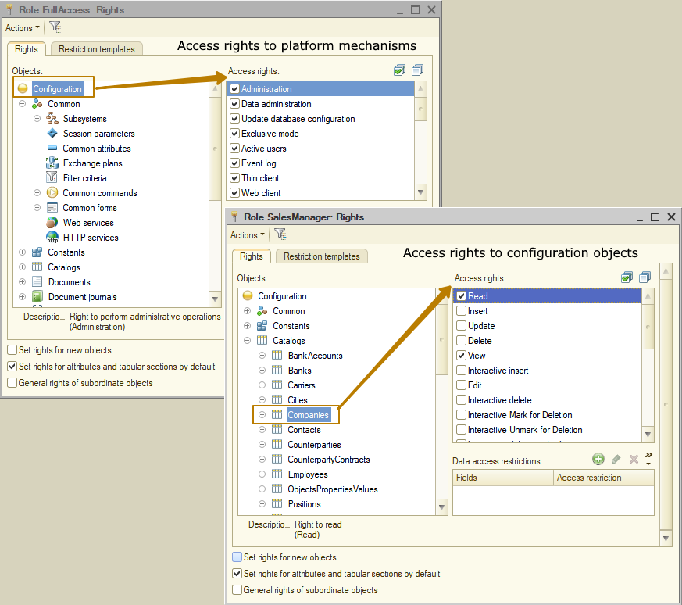
Object access rights are divided into two types:
- Basic (non-interactive) - always checked regardless of the method of accessing the objects of the information base.
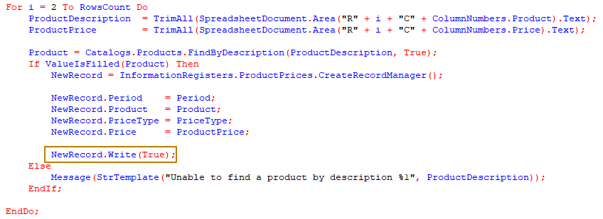
- Interactive - checked when performing interactive operations (for example, the operations "Set deletion mark", "Post", "Clear posting").
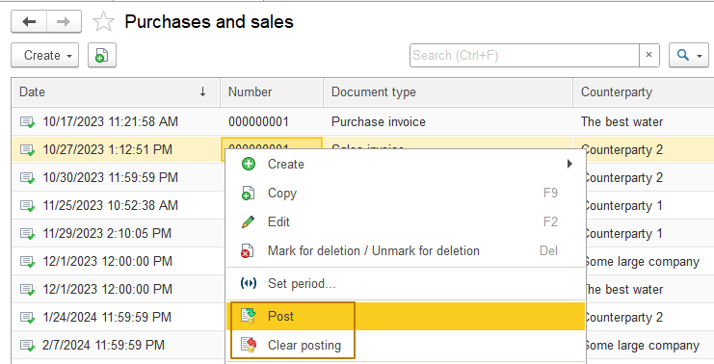
It should be taken into account that the check of interactive rights can be bypassed, for example, by creating a form yourself during configuration and replacing the standard commands with your own, but the check of non-interactive rights cannot be bypassed under any circumstances. Non-interactive rights protect the fundamental functionality characteristic of the object, this is the responsibility of basic access rights: "Insert", "Read", "Update", "Delete". To build secure application solutions, it is enough to manage only these 4 access rights.
The 1C:Enterprise system allows checking rights from the built-in language. For example, when adding commands to forms, the developer must additionally take care of checking the corresponding interactive rights.
Example of checking rights from the language:
&AtServer
Procedure OnCreateAtServer(Cancel, StandardProcessing)

If AccessRight("InteractiveDelete", Metadata.Documents.Document1) Then
Items.ButtonDeleteDocument1.Enabled = True;
Else
Items.ButtonDeleteDocument1.Enabled = False;
EndIf;

EndProcedure
For details, see the syntax assistant.
It is important to remember that the infobase user may have different interactive and non-interactive rights to a particular object. For example, the right "Posting" may be allowed, while the right "Interactive posting" may be prohibited.

When attempting to perform an unauthorized operation, an error message "Access violation!" is displayed, and all started transactions are canceled. Checking the basic and interactive rights is used by form, table field, and input field extensions (the form extension is determined by its main attribute, and the table field and input field extension is determined by the type of edited data). Due to this, if the "View" right is not set, the list form or object form will not open, and a standard message about an access rights violation will be displayed.
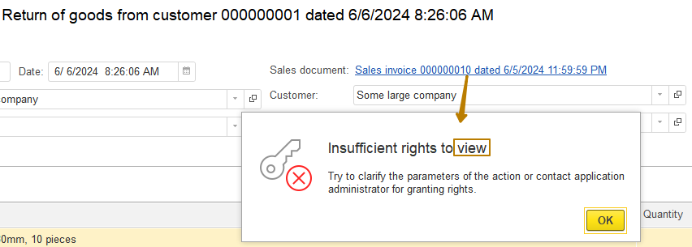
Let's review the verification of rights by form, table field, and input field extensions using a document as an example:
When opening a document form, the "View" right is checked, after which, if this is a new object form, the "Interactive insert" right is checked, and if not, the "Edit" right. If a write with posting is performed, the "Interactive posting", "Interactive undo posting" or "Interactive posting regular" rights are checked, depending on the writing mode.
The table field extension for a document journal, when opening a form in which the journal is set as the main attribute, checks that the "View" right is set for a7t least one document in the journal. When posting documents from the journal, the "Interactive posting", "Interactive undo posting" or "Interactive posting regular" rights are checked. When deleting documents, the "Interactive delete" right is checked, and when setting/unsetting a deletion mark, the "Interactive mark for deletion" and "Interactive unmark for deletion" rights are checked. When adding a new document, after selecting its type, the document journal table field extension checks the "Interactive insert" right. The document input field only checks the "String input" right.
Related rights
Some rights in the 1C:Enterprise system are related to each other. This means that basic access rights, such as "Read", "Update", "Insert" and "Delete" and some others, can affect the rights responsible for such operations with an object, which will ultimately lead to the simplest operations. For example, you cannot allow the "Update" right without granting the "Read" right.

Interactive rights directly depend on their non-interactive analogs, i.e. the "Interactive delete" right depends on the "Delete" right. In practice, when configuring, this looks like this: when interactive rights are allowed, similar non-interactive ones will be automatically allowed, and vice versa, when non-interactive rights are removed, the corresponding interactive ones will be automatically reset. It is only possible to set a non-interactive right and reset an interactive one, but not vice versa. For example, you cannot allow the interactive right "Interactive delete" and prohibit the non-interactive "Delete".
The dependency of rights can be built into complex chains, for example, for the object "Document" the right "Interactive undo posting" depends on the rights "Undo posting" and "Edit" simultaneously, where the first depends on "Update", which, in turn, depends on the right "Read":
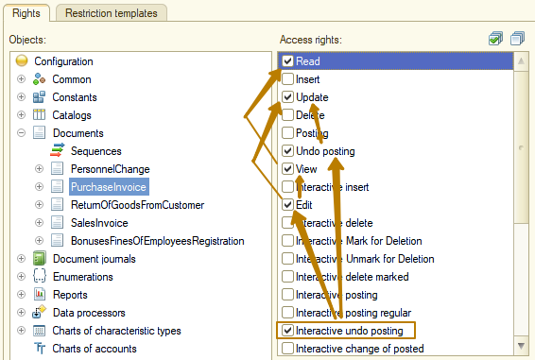
The key right is "Read", in its absence, any other rights to access the object are automatically lost.
Access right | Description
ActiveUsers | Allows viewing the list of active users. This right can be used when organizing "guest login" in the application solution.
Administration | Allows administrative actions such as maintaining a user list or opening a configuration.
Automation | Allows the use of 1C:Enterprise in automation mode.
Delete | Allows deletion
Edit | Allows editing of the object (interactive)
EventLog | Allows viewing of event logs and work protocols
ExclusiveMode | Allows switching to exclusive mode when working in 1C:Enterprise mode.
ExternalConnection | Allows the use of 1C:Enterprise via COM connection.
Insert | Allows adding objects of this type. Checked at the object level and at the DB level.
InteractiveDelete | Allows interactive direct deletion
InteractiveDeleteMarked | Allows interactive deletion of marked objects
InteractiveInsert | Allows interactive addition of objects of this type
InteractiveMarkForDeletion | Allows interactive setting of deletion marks
InteractiveOpenExtDataProcessors | Allows opening external data processors using standard menu commands
InteractiveOpenExtReports | Allows opening external reports using standard menu commands
InteractivePosting | Allows interactive posting of documents of this type
InteractivePostingRegular | Allows interactive postong (using standard form commands) of a document in regular (non-operational) mode
InteractiveUndoPosting | Allows interactive cancellation of document posting
InteractiveUnmarkForDeletion | Allows interactive removal of the deletion mark
Posting | Allows posting of documents
Read | Allows reading data from the infobase
StringInput | Enables the use of line input mode for various objects.
TotalsControl | Allows management of the totals of the accounting registers and the accumulation registers - setting the period for which the totals are calculated and recalculation of the totals
UndoPosting | Allows cancellation of document posting
Update | Allows modification of objects of this type. Checked at the object level and at the DB level.
Use | Allows the use of data processor, report, subsystem
View | Allows viewing of objects (for example, in lists)
Features of access rights working with forms
In the 1C:Enterprise platform, access rights are configured for application objects. Rights to open forms are not configured, with the exception of common forms.
When opening a form, the rights to the object that is the main attribute of the form are checked. The rights to the object to which the form is subordinated in the metadata object tree are not taken into account.
Thus, if a data processor form does not have a main attribute, the rights set for the data processor do not affect the ability of a user to open this form. Also, if the form is subordinate to one catalog (A), and the main attribute of the form specifies an object of another catalog (B), then the user's rights to the other catalog (B) will be taken into account.
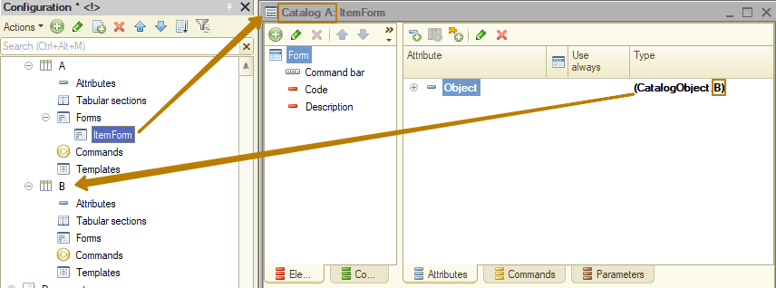
That is, the rights to open the form are determined not by the subordination of the form in the metadata tree, but by its main attribute.
Roles
Let's consider how exactly a user is granted access rights. To issue access rights in the 1C platform, a special mechanism "Roles" is used. It is a layer between the users of the information base and access rights. Each role combines a set of access rights, the assignment of which makes sense only at the same time. For example, in the role "Setting product prices" it is logical to combine sets of rights responsible for objects associated with this action (i.e. it is necessary to issue rights to the ProductPrices register, the Products catalog, if the register is subordinate to a recorder, then to the PriceSetup document, etc.). The simplest way to set a role for a user is to open the IB user card in the Designer mode and set the flags opposite the roles required by the user.
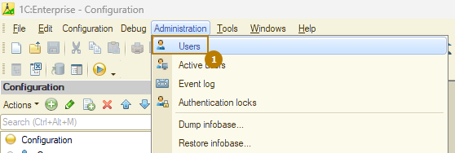
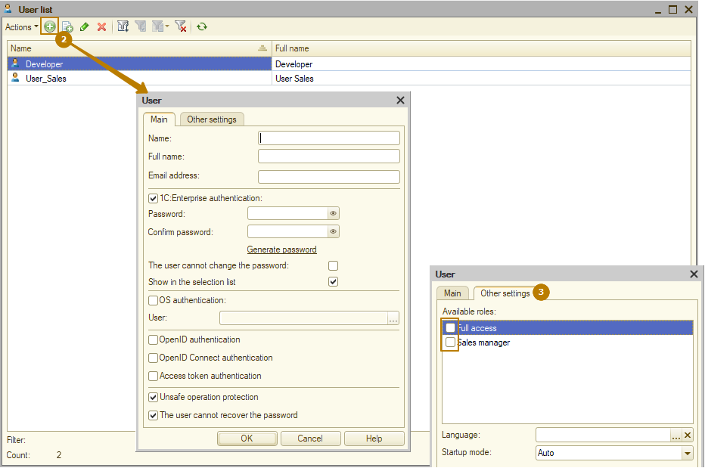
This is a universal method and it works in any configuration. In simple configurations or information bases for a small number of users, it can be successfully used, while the roles usually correspond to the job responsibilities of the users: CEO, Purchasing Manager, Sales Manager, Storekeeper, etc.
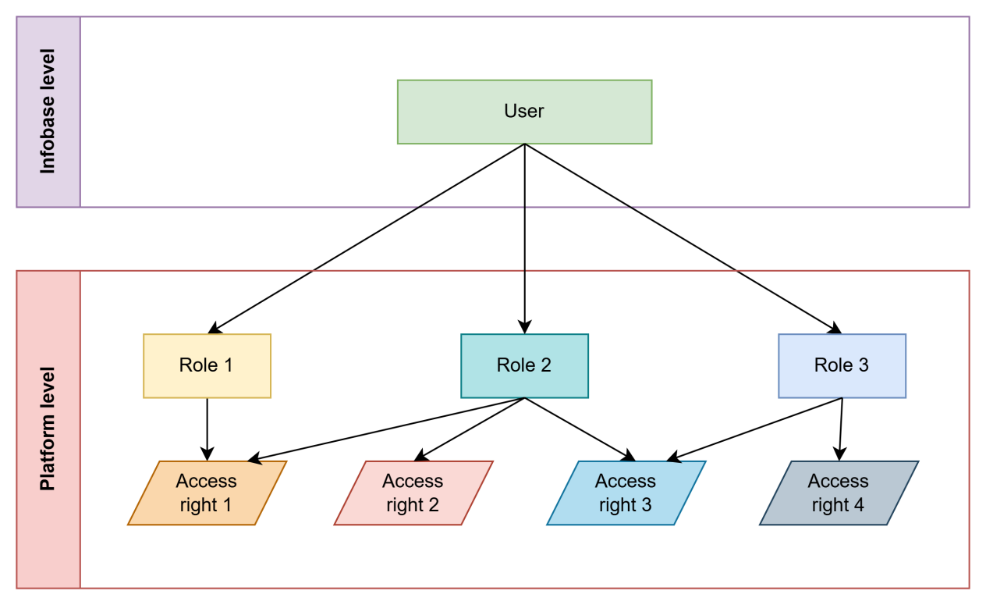
As configurations become more complex and the number of roles increases, this method becomes quite labor-intensive. For example, in a company with hundreds of users and regular personnel changes, roles corresponding to job responsibilities are not suitable, since it often happens that a specific employee has had his responsibilities expanded and now no role in the configuration suits him, and when several large roles are issued, he will receive excessive rights that he should not have. To avoid situations where a role gives many redundant rights, there is another scheme for combining access rights into roles - "granulated" roles that give rights directly to individual "small" functions, for example, ReadingSalesInvoice, AddChangePriceSetup, ReadCounterparties, SalesSubsystem. But in the large systems described above, when using granulated roles, it would be necessary to spend almost several hours daily to update the rights of all users, since each user needs to be given tens or even hundreds of roles.
That is why in current standard configurations based on the SSL (Standard Subsystems Library, which we will discuss in the following lessons), there is an additional layer between the IB user and roles. This layer is implemented as the "AccessManagement" subsystem. It allows you to combine roles into larger entities - "Profiles" and assign to the user not individual roles, but profiles containing sets of several roles.
This makes setting up rights more flexible, because you can, for example, create an Accountant profile with rights to set prices, for which you can combine roles, instead of creating another role in the configuration (which will require exclusive access to the database to update the DB configuration). Moreover, profiles can be created and changed in the Enterprise mode, which means that managing user rights can be faster and easier.
Let's consider the scheme for assigning access rights to users, used in most standard configurations. In a simplified form, it can be presented as follows. New entities "Access profile" and "Access group" are introduced. Each access profile includes several roles. And each user is assigned one or more access groups. Then, each access group is associated with an access profile. As a result, we get the ability to specify for the user not just roles, but sets of roles depending on the functions they perform ("Accountant with the right to set prices", "Regional sales manager", etc.).
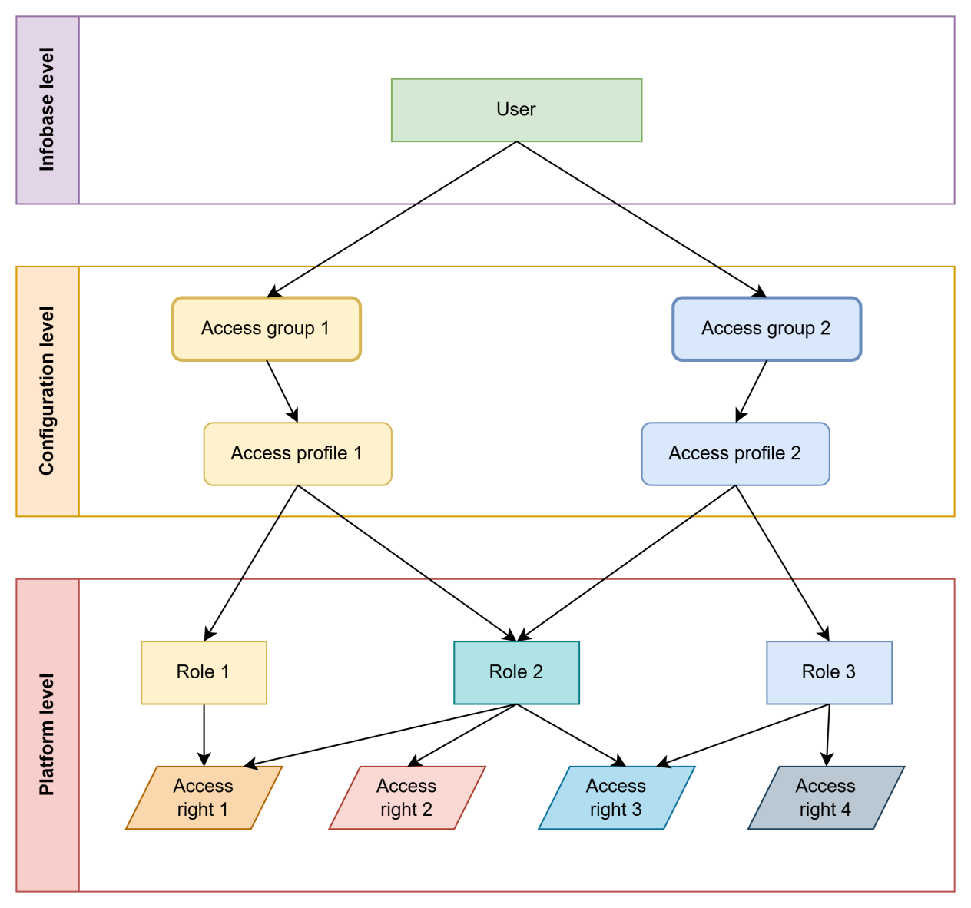
Mandatory roles
The configuration must define three mandatory roles that are intended for "applied" and system administration of the information base, as well as for interactive opening of external reports and data processors: FullAccess (synonym "Full access"), SystemAdministrator (synonym "System administrator") and InteractiveOpenExtReportsAndDataProcessors (synonym "Open external reports and data processors interactively").
- FullAccess - a mandatory role that provides unlimited access to all "applied" data of the information base, but does not provide access rights for administration of the information base as a whole (updating the configuration, working in the designer, etc.).
This role must:
- allow independent use (can be assigned to users);
- provide unlimited access to all data, except for the right of interactive deletion (details will be below);
- allow performing all administrative actions with data (user administration, program settings, deleting marked objects, etc.);
- include the following rights:
- Data administration
- Active users
- Event log
- Exclusive mode
- Thin client
- Web client
- Save user data
- Output
- SystemAdministrator is a mandatory role that provides additional rights to administer the information base as a whole (updating the configuration, working in the designer, etc.).
This role should:
- be assigned to users only together with the FullAccess role;
- provide unlimited access to all data in the information base (for complex configurations or cloud infobases);
- contain all access rights to objects (except for the right to interactively delete - details below);
- include all rights to the configuration root (in particular, the Administration and Data Administration rights), except for the Interactive opening of external reports and Interactive opening of external data processors rights.
- InteractiveOpenExtReportsAndDataProcessors is a mandatory role that provides additional rights to open external reports and data processors via the File - Open menu.
This role should:
- include rights to the root of the configuration “Interactive opening of external reports” and “Interactive opening of external data processors”.
The roles SystemAdministrator and FullAccess from the configuration Trade Management (the right "update configuration" is disabled for the role SystemAdministrator, since in this configuration there is a separate role for this right):
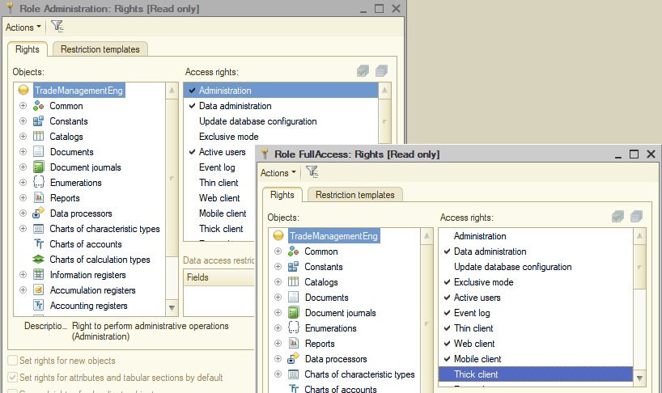
The FullAccess, SystemAdministrator and InteractiveOpenExtReportsAndDataProcessors roles must be set as the default roles of the configuration (the DefaultRoles property). Default roles are roles that are assigned to each user who starts the infobase when there are no users in the information base.
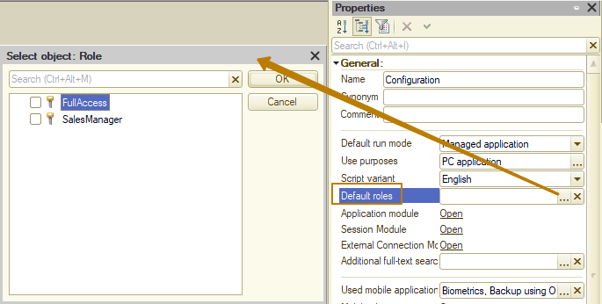
If the configuration requires users to set up general rights to work with the information base (such as "Thin client", "Thick client", "Interactive opening of external data processors", etc.), then the configuration must define separate roles to grant these rights. Such roles are not intended for independent use; they should be assigned to users together with other roles in the configuration.
The configuration must be equally designed to work both with these roles and in the absence of any of these roles for the user.
The following rights should not be set in any role, including FullAccess and SystemAdministrator (except in individual justified cases):
- Interactive delete
- Interactive deletion of predefined objects
- Interactive deletion mark on predefined objects
- Interactive removal of deletion mark from predefined objects
- Interactive deletion of marked predefined objects
It is recommended to leave the right to delete only in the FullAccess and SystemAdministrator roles. If it is necessary to allow users without full rights to delete objects, it is recommended to add a separate role DeleteMarkedObjects. This role is not intended for independent use; it should be assigned to users together with other configuration roles.
Setting rights for new objects and object attributes
When developing configuration roles, you should adhere to a method for setting permissions for metadata objects that does not allow roles to appear in the configuration that provide access to object fields but not to the object itself; and, as a result, avoid potential problems with setting access rights during deployment, when a user may mistakenly gain access to all metadata object attributes when assigning a similar role to them.
The "Set rights for new objects" checkbox should only be checked for the FullAccess role:
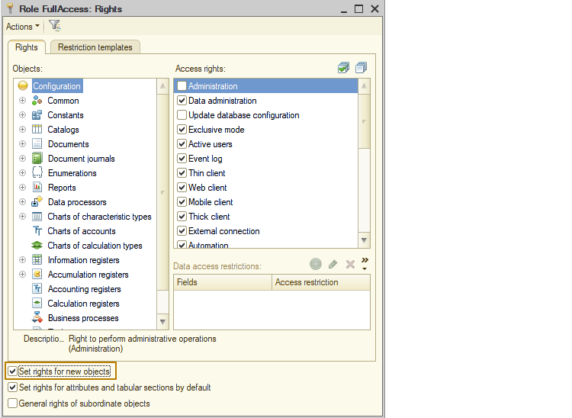
When adding a new role, the "Set rights for attributes and tabular sections by default" checkbox should be checked, and the "General rights for subordinate objects" checkbox should be unchecked.
If you need to set permissions for a role only for the fields of a metadata object (viewing, editing rights for attributes, table sections, dimensions, commands, etc., without these permissions for the object itself), the following is required beforehand. In the role, set the checkbox "General rights for subordinate objects", and uncheck the checkbox "Set rights for attributes and tabular sections by default" and clear the rights to all attributes and tabular sections.
When adding new objects or new fields of existing objects to the configuration, you should configure the rights to these objects or fields in the corresponding roles.
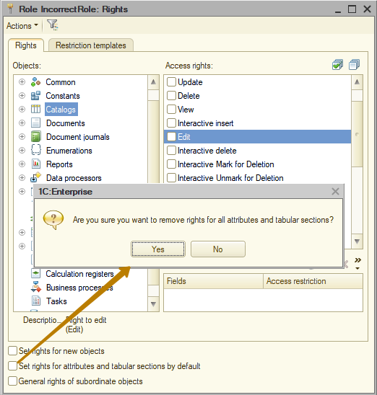
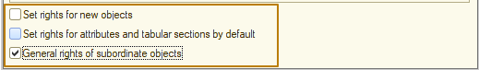
Checking if a user has a role
Sometimes, for the correct behavior of the program or the construction of the interface, it is necessary to check for the presence of certain rights of the user, in some cases, the use of so-called "flag" roles is suitable for this purpose, i.e. when a role does not grant any access rights by itself, but serves as a marker that the user who owns it has some rights (for example, to approve contracts).
To check for the presence of a role for the user, there is a method IsInRole(), which is used as follows:
If IsInRole("DocumentApproval") Then
Read the details in the syntax assistant.
Task
Since we currently have a fairly simple configuration with a small number of roles, we are quite satisfied with roles that correspond to job responsibilities. When creating roles of this type, you must first analyze the job responsibilities of the users who use or will use your application. In my case, I will start with the job responsibilities of "CEO", "PurchaseManager", "SalesManager", "Storekeeper", "HRM" and create the corresponding roles.
But I will start with creating mandatory roles. I add a new role, call it SystemAdministrator and assign rights to the configuration root. Then I repeat the steps for the FullAccess role:
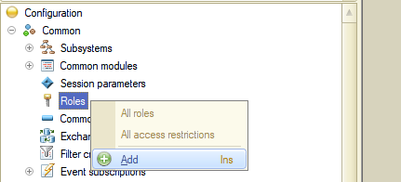
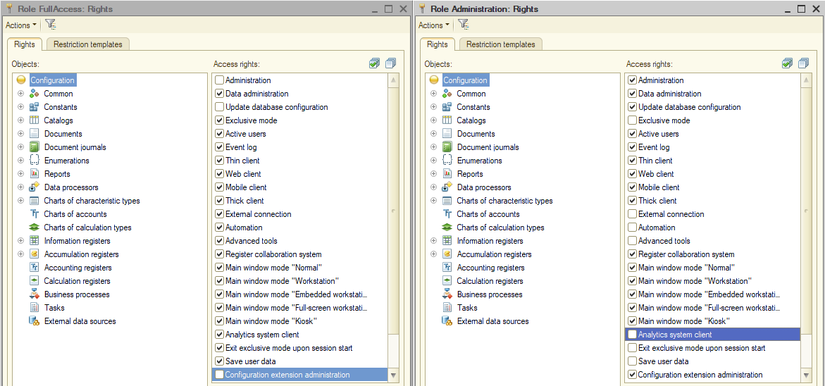
Since in my configuration these roles will always be used together for a full access user, I will leave the rights to access objects only for the FullAccess role. That is, the SystemAdministrator role will not have access rights to objects, only access rights to platform mechanisms.
Next, I grant the FullAccess role all access rights to all configuration objects except for the "Interactive delete" rights and the other rights listed in the "Mandatory roles" section.
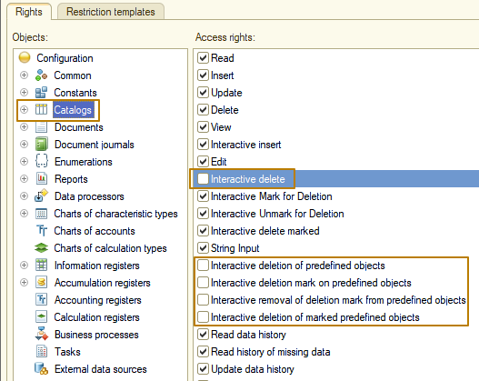
The role "InteractiveOpenExtReportsAndDataProcessors" is extremely simple - it gives only two access rights to the platform mechanisms: open external reports interactively and open external data processors interactively".
The next step is to create the “SalesManager” role and start by setting up access rights to the configuration root.
Information: when creating a new role, the rights "Thin client", "Web client", "Mobile client", all types of main window modes, the "Analytics system client" (a separate product from 1C, which is a BI system), "Save user data", and "Output" are already included in it. I recommend leaving these rights unchanged for roles that correspond to job responsibilities.
For atomic roles (i.e. small roles for individual functions), you should uncheck all access rights to the platform mechanisms, unless these are roles that grant one or more of these access rights (for example, the role "ThinClient" (for launching a thin client)).
After that, I move on to the access rights to objects. For the documents "Sales invoice" and "Return of goods from customer", I grant all rights except for deletion and rights to data history (this is a separate platform mechanism that we will not consider in this course). For the document "Purchase invoice", I grant only the rights "Read", "View" and "String input", since the sales department employees sometimes need to get some information on the purchase of goods.
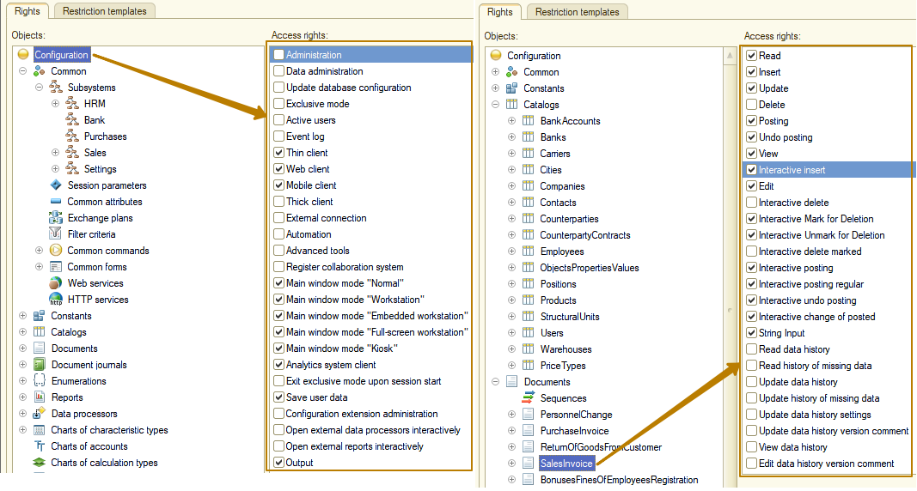
Next, I grant the rights "Read" and "View" to the accumulation registers related to sales and goods movement, otherwise the user will not be able to generate reports that receive data from these registers. There are only 2 rights for reports and data processors: "Use" and "View", I grant both of these rights for reports and data processor of loading prices from Excel.
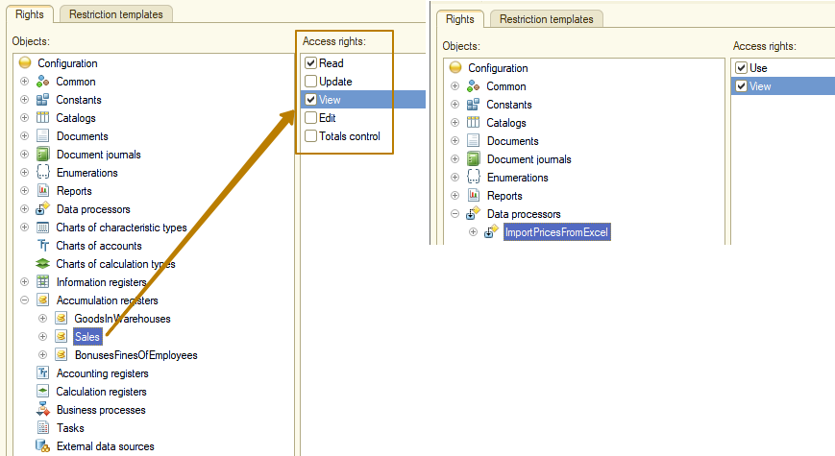
Since the data processor adds records to the price register, I must add the rights "Read" and "Update" to this register, but the sales manager has the right to change prices outside of a data processor, so I must also grant interactive rights - "View" and "Edit".
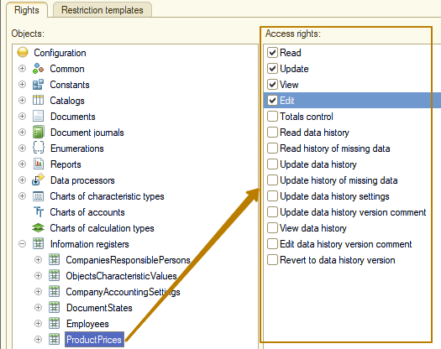
It is imperative to grant the "View" access right to the subsystems to which the user must have access. Otherwise, it will turn out that the user has access to catalogs and documents, but he will not be able to work with them, since they are not available from the interface, because the user does not see the subsystems in which these objects are located.
For commands and common forms, there is also only one access right - "View". Pay attention to the access rights to constants. If a user should have the right to read the values of constants, for example, whether the use of Characteristics is turned on, then it is necessary to grant the access right "Read", but if the user should also have the right to see the set values of these constants in forms, it is necessary to grant the access right "View". In this way, all the necessary access rights are configured, I recommend testing user access under each role (or access profile).
Now it's time to create the first users and assign them roles. I create users Administrator with 3 main roles
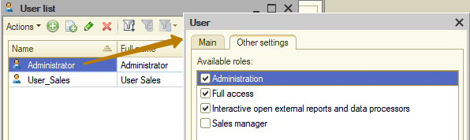
and User_Sales with the role "SalesManager", and then launch the database under each of these users. At the stage of launching the database, you can see the changes - now, when there is at least one user in the information base, at startup the platform requires authentication under a specific user:
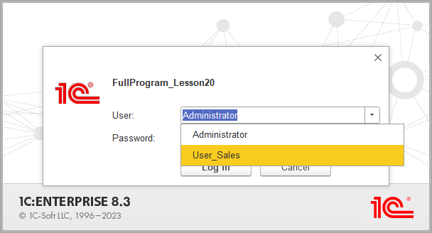
Nothing has changed when working on behalf of a user with full access, except that the "More" menu of referenced object forms no longer has the "Delete" button, which led to direct deletion of the object from the database (deletion of a table record at DB) without referential integrity checks (when the object could be referenced from other objects), which can lead to errors in the program. This button disappeared because I disabled the "Interactive delete" access right for all objects for the FullAccess role so that no one could perform such dangerous actions in the infobase.
Before:
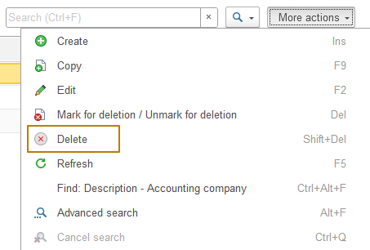
After:
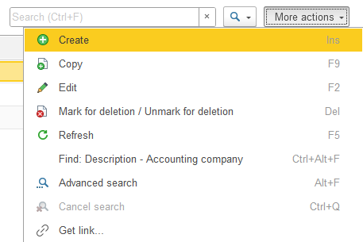
Now I launch the database as the User_Sales user. You can immediately see that not all subsystems are available to him:
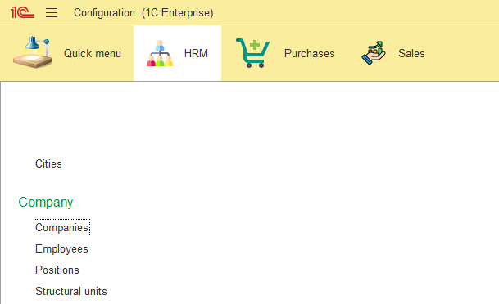
Let's try to open a form of some company. So, the platform displays a window with an access violation error.
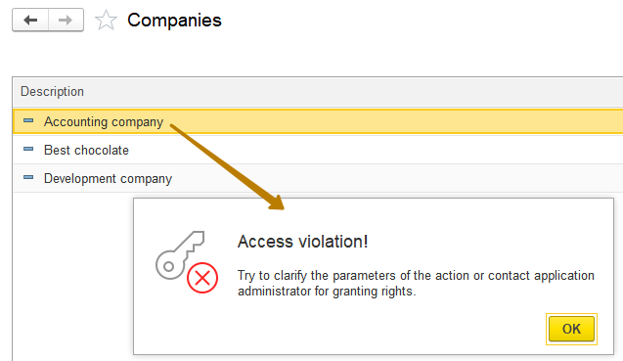
But why, since I granted the user role the right to read and view companies?
In order to find out which object the user does not have enough rights to, you can find the access error event in the event log, which is available to users with administrative rights in both modes: Designer and Enterprise.
In some cases, access rights errors are difficult to investigate, especially when they occur in the Try block, and the exception is not processed in sufficient detail or is not processed at all. But I was lucky - the cause of the error is obvious.
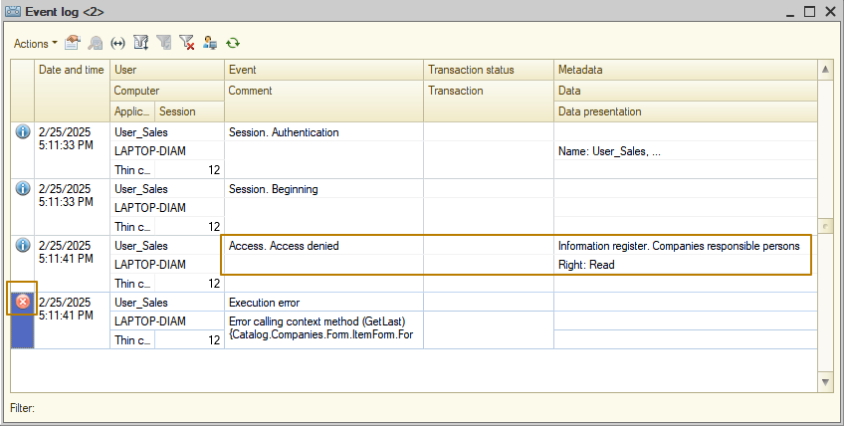
You can see that the record with the "Error" type is preceded by a record with access rights violation and the Metadata column indicates the metadata object - the "Companies responsible persons" information register, and the Data column indicates what access right the user lacks - "Read". In the line with the error, you can see where the code was called from, which led to an attempt to read this data, this is the Companies catalog form. Indeed, when creating the form on the server, we implemented an algorithm for reading responsible persons from the register. This error can be corrected in two ways:
1) quite obvious - issue the missing rights for the role used, the "Read" right is enough, since the user only reads data programmatically without displaying any of the forms with register data
2) temporarily disable access rights restriction. In cases where a user with a certain role should not have rights even to read some objects, but the algorithm uses reading of these objects, it is possible to execute some code in privileged mode - a mode when the user is allowed access to all objects of the system.
Of course, the first way suits us well, since there is no secret information in the register of responsible persons, but I would like to tell you how the execution of code in privileged mode works, so first we will consider the way of using this mode.
Privileged mode
In the topic about common modules, you already learned about the "Privileged" flag of a common module, turning on of which leads to the fact that all code executed inside such a common module is executed without restriction of access rights, and the module itself can only be server-side.
Sometimes you need to execute only a small part of the code without restriction of access rights, for example, to execute a query in which there is an access to tables for which many roles do not have the Read right, but the query result itself does not contain data prohibited for reading. In such cases, moving the execution of the code to a separate common module is not always a good solution, and therefore the platform has a SetPrivilegedMode(Boolean) method, which allows you to enable and disable the privileged mode for executing code without restriction of access rights.
To enable the privileged mode, you must pass True to the parameter of this method, to disable the mode - False. If you do not disable the privileged mode explicitly, it will be disabled implicitly when the procedure or function in which it was explicitly enabled ends.
I recommend always disabling it explicitly, because when developers work in a team, there can be a situation when another developer adds code to a procedure/function where you enabled and did not disable the privileged mode, which can lead to a situation where the code that should be executed with restricted access rights will be executed without restrictions.
An example of implicitly disabling the privileged mode upon exiting the procedure:
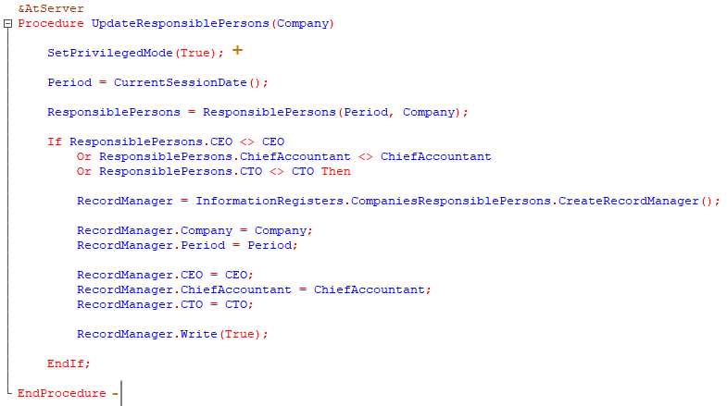
Example of explicitly disabling privileged mode:
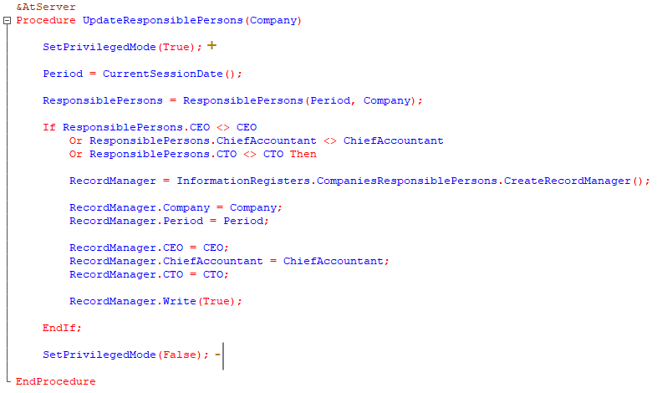
Incorrect use of privileged mode before a function call, because code that requires access rights checking may be executed inside the function:
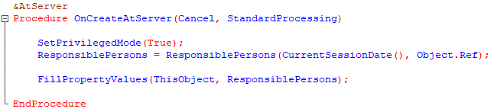
Correct use of privileged mode only before code for which access rights checking should be disabled:
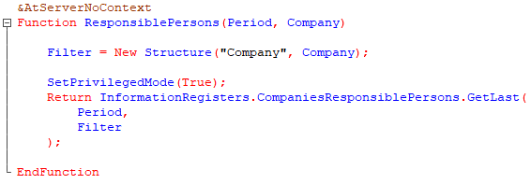
In the case when the privileged mode is enabled to execute the code after the Return operator (like at the previous image), there is no point in explicitly disabling the privileged mode after such a code, since the code after the Return operator will not be executed.

Information: In the client-server mode, the privileged mode can only be enabled on the server, calling the code to enable it on the client will not lead to anything.
So, I update the configuration and run the system under the User_Sales user, try to open a company form again and this time there is no error, i.e. data from the object to which the user does not have rights is successfully received.
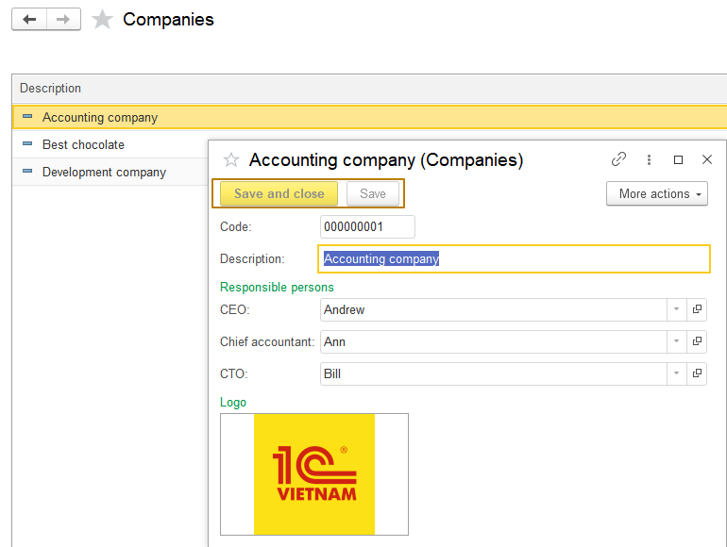
But, as I said earlier, in this case I do not see any obstacles why we should not give a user rights to read (and even view) this register, so I will still add them to the SalesManager role and to the other roles too, and then remove the code for setting the privileged mode when opening the organization form.
The company form module also contains code for recording in the register of responsible persons when recording a company. The rights to write to this register must be given to those roles that have rights to edit companies.
Information: setting the privileged mode is ineffective in situations where the user is shown data on objects to which he does not have the "View" right, for example, if the user does not have rights to a personnel document, then when returning this data to him after reading in privileged mode, among which there is such a document, the user will see a link to a non-existent object ("Object not found"):
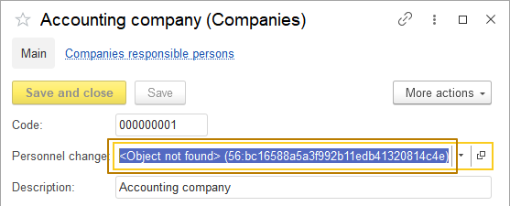
User authentication
Sometimes it is necessary to run debugging under another user to see the values of variables or the result of calculations with limited rights. This can be done quite simply, if the user does not have a password set - just open the menu Tools - Options, in the window that opens, go to the tab 1C:Enterprise startup and in the "User" area select the "Name" setting.
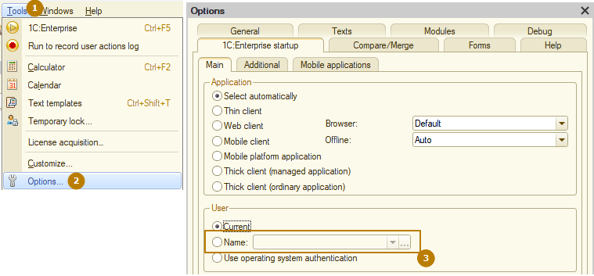
Then you can leave the field empty, then at each launch the platform will prompt you to select a user to launch. Or you can select a specific user, then there are 2 options:
- If the user does not have a password set, the launch on behalf of this user will be performed immediately
- If the user has a password set, an authentication window will open, where the user name is already selected (but it can be changed) and you need to specify his password to log in
By the way, sometimes it is necessary to hide a user from the list for security purposes, so that his name can only be entered manually, this can be done by unchecking the "Show in the selection list" flag in the user window:
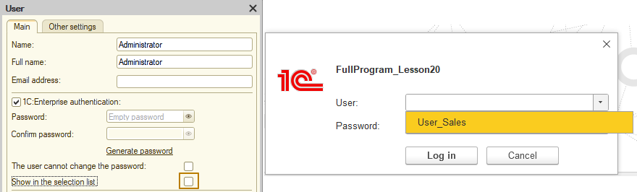
In addition to authentication by means of the 1C:Enterprise platform, there is also OS authentication, when an operating system user is specified for a 1C user. When such an OS user logs into the information base, the platform will search whether it is specified for any 1C user; if so, then the login will be performed on behalf of this 1C user without displaying the authentication window.
If neither of the two authentication methods (1C:Enterprise authentication and OS authentication) is specified for a user, then such a user will have an icon with a question mark in the list of users, though there are other authentication methods via OpenID, OpenID Connect and an access token at the platform.
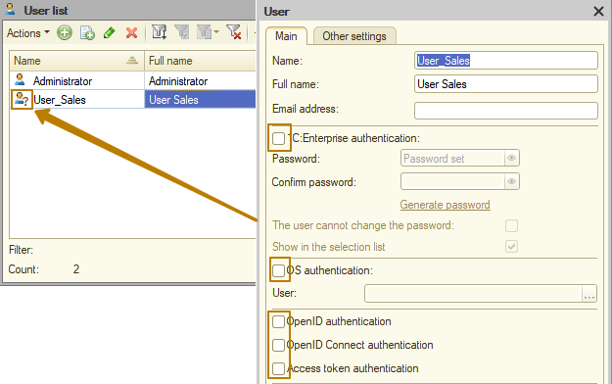
Unsafe operation protection
The last thing I want to talk about is the mechanism of protection from unsafe operations.
A special mechanism for protection from unsafe operations is provided to help the administrator of the application solution. When a potentially dangerous operation is performed, the system issues a warning containing information about the operation being performed and the potential danger of this operation. Potentially dangerous operations include:
- Running an external processing (report) or configuration extension.
- Running or updating a configuration/extension.
- Access from an external data processor (report) or an extension to the following capabilities:
- Loading another external data processor (report)
- Executing an operating system command
- User management
- Loading an external component
We have already seen an example of such a warning in the lesson on data processors, when I opened an external data processor from a file.
To configure this protection for individual users, there is a flag in the user properties called "Unsafe operation protection", which is enabled by default when a user is created. In general, I do not recommend unchecking it:
